Safeguarding and Child protection at Stokes Bay Sailing Club
March 2022
Policy Statement
Stokes Bay Sailing Club is committed to ensuring that everyone who takes part in the sport should be able to do so in an enjoyable and safe environment, which promotes inclusion and protects from harm, bullying and abuse. We recognise that the safety, welfare and needs of the child are paramount and that any child, irrespective of age, disability, race, religion or belief, sex, sexual or gender identity or social status, has a right to protection from discrimination and abuse.

Stokes Bay Sailing Club takes all reasonable steps to ensure that through appropriate operating procedures and training, it offers a safe and fun environment to children and young people taking part in its events and activities.
For the purposes of this policy anyone under the age of 18 should be considered as a child.
“ Safeguarding is everyone’s responsibility” Statutory guidance ‘Working Together to Safeguard Children’ 2018) Therefore all members of the Club should be aware of this policy.
Club Welfare Officer
The Club Welfare Officer is: Andy Wealthy : SBSCwelfare@hotmail.com 07919 537477
Staff and Volunteers
All Club staff and volunteers whose role brings them into regular contact with young people will be given training in Safeguarding and made aware of reporting procedures. The club will appoint a Welfare Officer, someone who is a familiar face around the club and who will be asked to apply for an Enhanced Criminal Records Disclosure. In addition, those regularly instructing, coaching or supervising young people will also be asked to apply for an Enhanced Criminal Records Disclosure, with Barred List check if appropriate. This will be the supervising team of parent-leaders Cadets.
Good Practice
All members of the Club should follow the Good Practice Guidelines (see below) and agree to abide by the Club Code of Conduct (see below) and the RYA Racing Charter contained in the Racing Rules of Sailing. Those working or volunteering with young people should be aware of the guidance on recognising abuse. Appendix A
Changing Rooms
Parents should use their best judgement when deciding whether to accompany their child in the changing rooms. The NSPCC suggests that all children under the age of 8 should be accompanied and as such children under the age of 8 should be able to accompany their parent in the changing rooms even if they are of the opposite sex. It is the responsibility of all members to ensure their behaviour and language is appropriate when there are children or young people in the changing rooms.
The Club will seek consent from parents/carers before taking photos or video of a child at an event or training session or publishing such images. Parents and spectators should be prepared to identify themselves if requested and state their purpose for photography/filming. If the Club publishes images of children, no identifying information other than names will be included and photos will be displayed in the closed Club Cadet Facebook group only. Any concerns about inappropriate or intrusive photography or the inappropriate use of images should be reported to the Club Welfare Officer.
Concerns
Anyone who is concerned about a young member’s or participant’s welfare, either outside the sport or within the Club, should inform the Club Welfare Officer immediately, in strict confidence. The Club Welfare Officer will follow the attached procedures (see RYA Flowcharts 1 and 2).

Any member of the Club failing to comply with the Safeguarding policy or any relevant Codes of Conduct may be subject to disciplinary action under Club Rule 14.

Good Practice Guidelines
This guide only covers the essential points of good practice when working with children and
young people. You should also read the organisation’s Child Protection Policy and Procedures
which are available for reference at all times.
You should:
• Avoid spending any significant time working with children in isolation
• Do not take children alone in a car, however short the journey
• Do not take children to your home as part of your organisation’s activity
• Where any of these are unavoidable, ensure that they only occur with the full knowledge
and consent of someone in charge of the organisation or the child’s parents
• Design training programmes that are within the ability of the individual child
• If a child is having difficulty with a wetsuit or buoyancy aid, ask them to ask a friend to help
if at all possible
• If you do have to help a child, make sure you are in full view of others, preferably another
adult
• Restrict communications with young people via mobile phone, e-mail or social media to
group communications about organisational matters. If it’s essential to send an individual
message, copy it to the child’s parent or carer
You should never:
• engage in rough, physical or sexually provocative games
• allow or engage in inappropriate touching of any form
• allow children to use inappropriate language unchallenged, or use such language yourself
when with children
• make sexually suggestive comments to a child, even in fun
• fail to respond to an allegation made by a child; always act
• do things of a personal nature that children can do for themselves.
It may sometimes be necessary to do things of a personal nature for children, particularly if they
are very young or disabled. These tasks should only be carried out with the full understanding
and consent of the child (where possible) and their parents/carers. In an emergency situation
which requires this type of help, parents should be fully informed. In such situations it is important
to ensure that any adult present is sensitive to the child and undertakes personal care tasks with
the utmost discretion.
Disclosure:
If a child or adult discloses information about Safeguarding you should:
- Give time to listen non judgementally
- Make accurate notes quoting the language and phrasing used by the child/adult
- Pass on your concerns to the Club Welfare Officer immediately
- Not promise confidentiality – explain that the information you are given may have to be passed on to the appropriate people
- Do not approach any person who has been accused of a safe guarding incident
- Support the child/adult appropriately

Club Code of Conduct
It is the policy of Stokes Bay Sailing Club that all members, participants, coaches, instructors,
officials, parents and volunteers show respect and understanding for each other, treat
everyone equally within the context of the sport and conduct themselves in a way that
reflects the principles of the club/class. The aim is for all participants to enjoy their sport
and to improve performance.
Abusive language, swearing, intimidation, aggressive behaviour or lack of respect
for others and their property will not be tolerated and may lead to disciplinary
action.
Participants - young sailors, windsurfers and powerboaters
• Listen to and accept what you are asked to do to improve your performance and keep
you safe
• Respect other participants, coaches, instructors, officials and volunteers
• Abide by the rules and play fairly
• Do your best at all times
• Never bully others either in person, by phone, by text or online
• Take care of all property belonging to other participants, the club/class or its members
Parents
All parents/guardians are responsible for looking after their own children during activities and are NOT to leave the vicinity of the club or water when their children are taking part.
• Support your child’s involvement and help them enjoy their sport
• Help your child to recognise good performance, not just results
• Never force your child to take part in sport
• Never punish or belittle a child for losing or making mistakes
• Encourage and guide your child to accept responsibility for their own conduct and
performance
• Respect and support the coach
• Accept officials’ judgements and recognise good performance by all participants
• Use established procedures where there is a genuine concern or dispute
• Inform the club or event organisers of relevant medical information
• Ensure that your child wears suitable clothing and has appropriate food and drink
• Provide contact details and be available when required
• Take responsibility for your child’s safety and conduct in and around the
clubhouse/event venue
Coaches, Instructors, Officials and Volunteers
• Consider the welfare and safety of participants before the development of
performance
• Encourage participants to value their performance and not just results
• Promote fair play and never condone cheating
• Ensure that all activities are appropriate to the age, ability and experience of those
taking part
• Build relationships based on mutual trust and respect
• Work in an open environment
• Avoid unnecessary physical contact with young people
• Be an excellent role model and display consistently high standards of behaviour and
appearance
• Do not drink alcohol or smoke when working directly with young people
• Communicate clearly with parents and participants
• Be aware of any relevant medical information
• Follow RYA and club/class guidelines and policies
• Holders of RYA Instructor and Coach qualifications must also comply with the RYA
Code of Conduct
• Holders of RYA Race Official appointments must also comply with the RYA Race
Officials Code of Conduct.
If you are concerned that someone is not following the Code of Conduct, you should
inform your Club Welfare Officer or the person in charge of the activities

Appendix A
What is Child Abuse?
(Based on the statutory guidance ‘Working Together to Safeguard Children’ 2018)

The full document can be found on the RYA website under “Safeguarding”. What follows is a simplified version of the original document.
Abuse and neglect are forms of maltreatment of a child. Somebody may abuse or neglect a child
by inflicting harm, or by failing to act to prevent harm. Children may be abused in a family or in an
institutional or community setting by those known to them or, more rarely, by others (including via
the internet). They may be abused by an adult or adults, or another child or children.
Physical abuse may involve adults or other children inflicting physical harm such as :
• hitting, shaking, burning, drowning or suffocating
• giving children alcohol or inappropriate drugs
• in sport situations, physical abuse might also occur when the nature and intensity of
training exceeds the capacity of the child’s immature and growing body.
Emotional abuse is the persistent emotional maltreatment of a child such as to cause severe and persistent adverse effects on the child’s emotional development. It may involve:
• saying they are worthless, unloved or inadequate
• not giving them a chance to express their views, silencing them or
‘making fun’ of what they say or how they communicate
• imposing expectations beyond the child’s age or capability
• preventing the child from participating in normal social interaction
• serious bullying (including cyber bullying), causing children frequently to feel frightened or
in danger
• emotional abuse in sport might also include situations where parents or coaches subject
children to constant criticism, bullying or pressure to perform at a level that the child
cannot realistically be expected to achieve.
Some level of emotional abuse is involved in all types of maltreatment of a child.
Sexual abuse. Sexual abuse involves an individual (male or female, or another child) forcing or
enticing a child or young person to take part in sexual activities, whether or not the child is aware of what is happening.

Neglect is the persistent failure to meet a child’s basic physical and/or psychological needs, likely to result in the serious impairment of the child’s health or development. Neglect may involve a parent or carer failing to:
• provide adequate food, clothing and shelter
• protect a child from physical and emotional harm or danger
• ensure adequate supervision
• ensure access to appropriate medical care or treatment
• respond to a child’s basic emotional needs
• neglect in a sport situation might occur if an instructor or coach fails to ensure that children
are safe, or exposes them to undue cold or risk of injury.
Bullying (including online bullying, for example via text or social media) may be seen as
deliberately hurtful behaviour, usually repeated or sustained over a period of time, where it is
difficult for those being bullied to defend themselves. The bully is often another young person.
Although anyone can be the target of bullying, victims are typically shy, sensitive and perhaps
anxious or insecure. Sometimes they are singled out for physical reasons – being overweight or
physically small, being gay or lesbian, having a disability or belonging to a different race, faith or
culture.
The acronym STOP – Several Times On Purpose - can help you to identify bullying behaviour.
Recognising Abuse
It is not always easy, even for the most experienced carers, to spot when a child has been
abused. However, some of the more typical symptoms which should trigger your suspicions
would include:
• unexplained or suspicious injuries such as bruising, cuts or burns, particularly if situated
on a part of the body not normally prone to such injuries
• sexually explicit language or actions
• a sudden change in behaviour (eg. becoming very quiet, withdrawn or displaying sudden
outbursts of temper)
• the child describes what appears to be an abusive act involving him/her
• a change observed over a long period of time (eg. the child losing weight or becoming
increasingly dirty or unkempt)
• a general distrust and avoidance of adults, especially those with whom a close relationship
would be expected
• an unexpected reaction to normal physical contact
• difficulty in making friends or abnormal restrictions on socialising with others.
It is important to note that a child could be displaying some or all of these signs, or behaving in a
way which is worrying, without this necessarily meaning that the child is being abused. Similarly,
there may not be any signs, but you may just feel that something is wrong. If you have noticed a
change in the child’s behaviour, first talk to the parents or carers. It may be that something has
happened, such as a bereavement, which has caused the child to be unhappy.
If you are concerned
If there are concerns about sexual abuse or violence in the home, talking to the parents or carers
might put the child at greater risk. If you cannot talk to the parents/carers, consult your
organisation’s designated Welfare/Safeguarding Officer or the person in charge. It is this
person’s responsibility to make the decision to contact Children’s Social Care Services or the
Police. It is NOT their responsibility to decide if abuse is taking place, BUT it is their responsibility
to act on your concerns.

Reporting Procedures
In the first instance please report your concerns to the Club Welfare Officer
If you are uncertain what to do at any stage, contact the RYA’s Safeguarding and Equality
Manager on 023 8060 4104 or the NSPCC free 24-hour helpline 0808 800 5000.
Details of Children’s Social Care departments and emergency duty teams are listed on local
authority websites and in local phone books. If you are unable to find the appropriate contact
number, call the RYA’s Safeguarding and Equality Manager or, if a child is at immediate risk, the
Police.
Flow Chart 1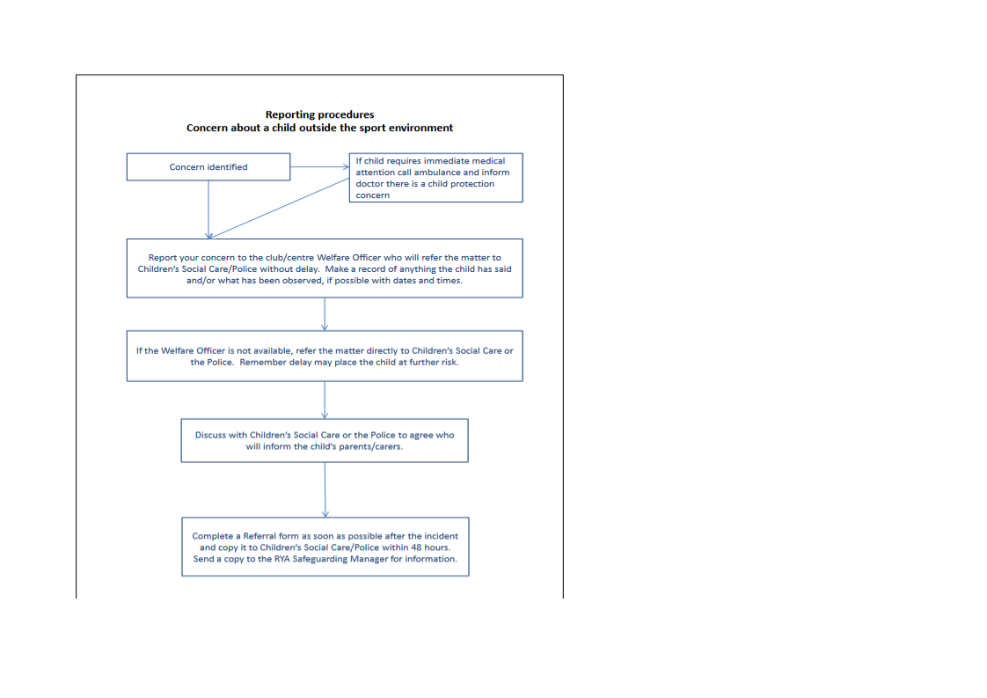

Flow Chart 2

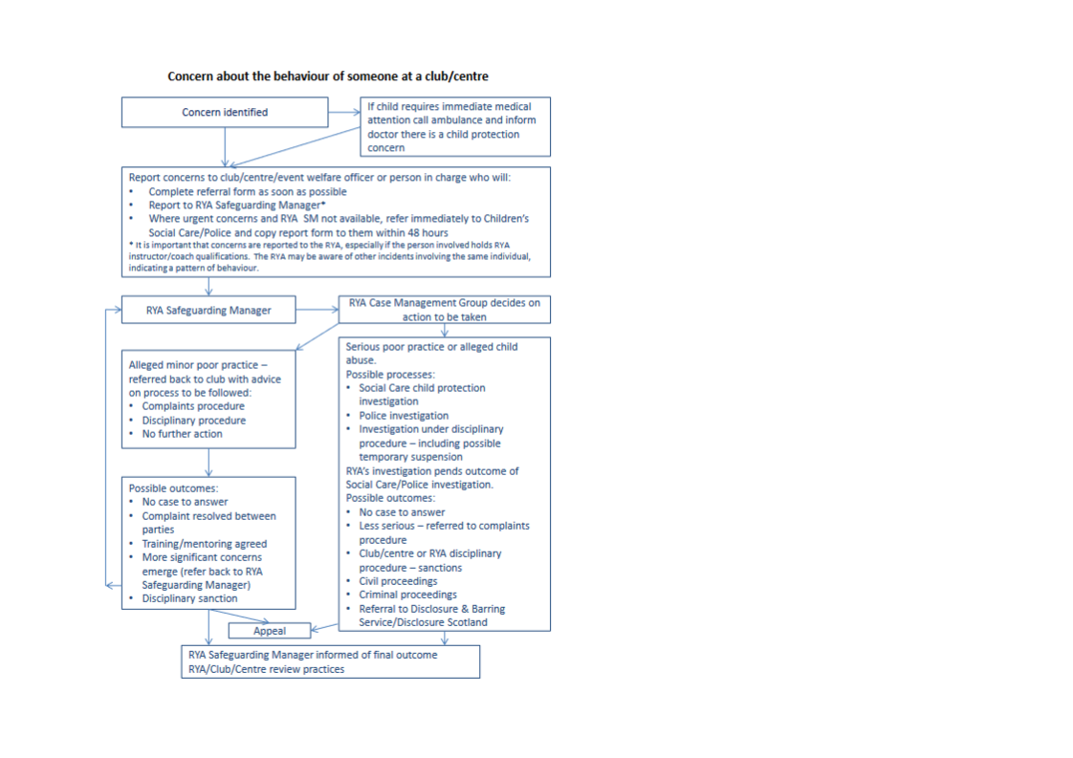
PART 2 – PROCEDURES
3 Designated Person
Although everyone has a role to play in ensuring that children are safe, it is recommended that a designated individual has specific responsibility for implementing your policy. This will be the Club Welfare officer. They should inform the RYA Safeguarding Manager when they are appointed, to ensure that they receive relevant information and advice.

In a club it could be a volunteer, ideally someone with relevant knowledge and experience, who is perceived as being approachable and having a child-centred approach. They don’t need to be an expert – that is the role of Children’s Services and the Police. If they haven’t received any previous training, this can be done through the RYA.

The designated person’s role description could include:

- Maintaining up-to-date policy and procedures, compatible with the RYA’s in conjunction with the club management committee ( Club Secretary)
- Ensuring that relevant staff and/or volunteers are aware of and follow the procedures.
- Advising the management committee on safeguarding and child protection issues.
- Maintaining contact details for local Children’s Services and Police.
If you are unable to obtain contact details from your local authority’s website or the phone book, the RYA Safeguarding and Equality Manager can provide this information on request.

If there is a concern, the designated person would:

- Be the first point of contact for any concerns or allegations, from children or adults, ensuring that confidentiality is maintained in all cases.
- Decide on the appropriate action to be taken, in line with the organisation’s procedures and in conjunction with the person in charge (Commodore, Principal etc).
- Keep the RYA informed as necessary

Everyone in the organisation should know who the Welfare Officer is and how to contact them. An RYA poster for clubs and training centres to display this information can be downloaded from the RYA website www.rya.org.uk/go/safeguarding or contact the Safeguarding and Equality Manager (see below).

RYA designated person
For further details or if you have any concerns, please contact Katie Loucaides, RYA Safeguarding and Equality Manager: safeguarding@rya.org.uk or tel:023 80604104 or Gayle Logan on dsco.ryani@gmail.com tel: 028 91827154

Code of Conduct for Volunteer Welfare Officers
The role of the welfare officer is to:
1. Be clear about the club’s responsibilities when running activities for children and young people
2. Help those actively involved with children and young people to understand what their duty of care means on a day to day basis
As a Welfare Officer you agree to act as a role model to others in accordance with the roles and responsibilities outlined in the role description and person specification. In taking up the position of Welfare Officer you are agreeing with this code of conduct and will accept that within the role of welfare officer you will:
• Undertake an enhanced disclosure check
• Be child centred at all times and promote a safe and fun environment for children and young people
• Implement the RYA’s safeguarding children policies and guidelines within your club
• React in a calm and collected manor if safeguarding concerns are brought to your attention
• Champion best practice within your club
• Engage with the RYA safeguarding team and pass on any serious poor practice or safeguarding concerns in line with the “When to refer to the RYA” guidance
• If required, attend board meetings with the club committee
• Manage and deal with poor practice issues in an appropriate and timely manner
• Ensure appropriate levels of confidentiality and data security are always maintained
• Assist with the implementation of safe recruitment for paid staff and volunteers within your club. This includes, ensuring that anyone in regulated activity is subjected to the appropriate disclosure check ( this will be the parent-leaders team of Cadets)
• Be open to personal development opportunities provided by the RYA safeguarding team

