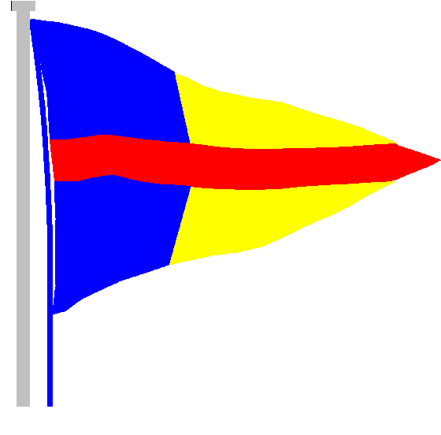
STOKES BAY SAILING CLUB

The Promenade, Stokes Bay Road, Gosport, PO12 2BL
Tel: 023 9258 1513
Email: administrator@stokesbay-sc.co.uk

22nd October 2021
Re: Covid cases rising

Dear members,

We ask that you and your guests adhere to the following rules and guidelines which are based on the premise that cases are rising, especially in Gosport, and there are vulnerable people within our sailing club community.

RULES:
Masks
We ask that you wear a mask in the club building unless you are seated at a table. We are asking this so that more vulnerable members are able to enjoy the club.

Changing rooms
These will continue to operate with reduced occupancy because our changing rooms are underground where ventilation is poor. Please continue to tab in and out as you enter and exit the changing rooms and remove your bag from the changing room after you have changed.
Changing room | Occupancy | Showers
Male | 8 | Only 4 allowed at one time with one on each side.
Female | 5 | All showers can be used.

GUIDELINES:
Galley
We invite you to order from the galley and maintain distance when queueing. Jo will no longer assign tables, but you are welcome to reserve a table through Jo.

Bar
The bar staff will offer table service and if you choose to order from the bar, we ask that you stand on the tape placed on the floor and do not crowd the bar.

Jingle Bell Ball – Friday 3rd December
Halloween Games Night – Saturday 30th October
Prize Giving - Saturday 20th November
AGM - Sunday 5th December
We will review the situation and guidance nearer the time but for now these events are running as planned.

Tickets for the Jingle Bell Ball have been selling well and we still have some available so please get in touch with Deb at administrator@stokesbay-sc.co.uk if you would like to purchase any. Unless we are subject to government guidance, we will be running this as a mask-free event however you are welcome to decide whether to wear a mask or not.

As always, we will review these rules and guidelines as the days and weeks progress.

Many thanks and happy sailing.
The Management Committee

