Stokes Bay Sailing Club’s Administrator, Debbie Wood is retiring after 25 years of loyal and resolute service.
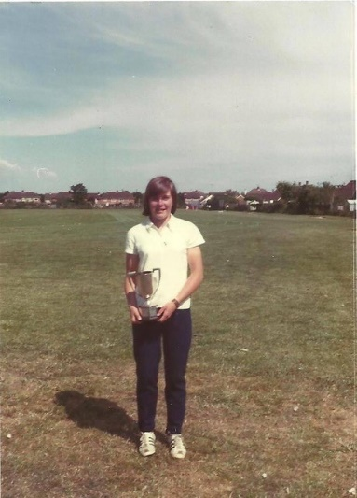
Growing up in Alverstoke, Debbie joined SBSC as a cadet, and went on to serve numerous committees up to Vice-Commodore, and so her association with SBSC goes back more than 50 years. Debbie’s depth of knowledge and experience has been indispensable in supporting some ten Commodores and their Committees, and likewise as Club Administrator where she has diligently served a membership that peaked to over 800-strong; handled a disparate array of questions and requests from our members; maintained our buildings and equipment (even to the point of heroically unblocking drains and urinals and beer pumps – though thankfully never all on the same day!); run all of our finances and accounts and for many years the bar; organised weekly sailing duty rotas; and countless other tasks. Furthermore, Debbie has organised and run hundreds of successful sailing events for Stokes Bay, from local regattas to class worlds. Simply put, what Debbie does not know about the world of dinghy sailing and SBSC is probably not worth knowing. Debbie is also known for her canine companions, from Archie the infamous beer drinking chocolate lab to her current partner in crime, Cedric the cockapoo.
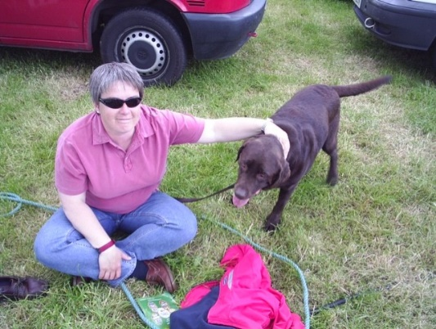
Whilst doing all of this for our Club, Debbie supported both parents through long illnesses as well as giving her free time to provide care in the community service.
Debbie will leave a big hole in the SBSC sailing community. We wish her well for her new life, which she plans to spend on long walks with her partner Carol (and of course Cedric!) and drinking copious cups of cappuccino with her friends. There is even a rumour that we will see Debbie back where it all started some 50 years ago on the water at the pin-end of a Stokes Bay SC start-line.
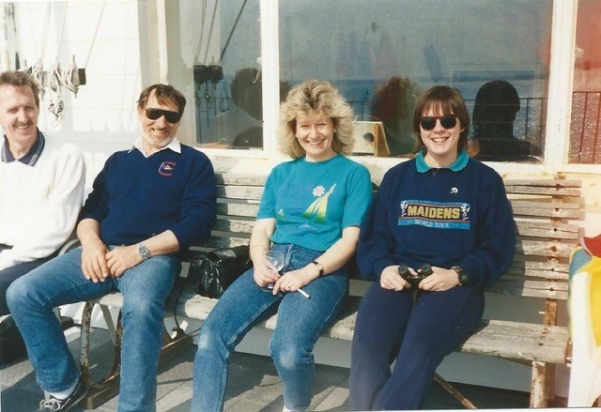
SBSC owes a huge debt of thanks to Debbie, for her service and her passion for our Club. She has been there every step of our recent past, helping guide and counsel and support the club and its members and committees. We were honoured to have Debbie as part of the Stokes Bay SC family, and for all at SBSC to call her a friend. We wish you every happiness for the future Debbie; take that overdue break, relax, and socialise, and be assured the club is in safe hands, and wish us luck in the search for your successor.
We are excited to share that we will be hiring a new administrator for the club. It is an outward facing role and we are looking for someone who can work flexible hours with more hours in the summer than the winter. The administrator supports the work of the voluntary Management and Sailing committee and establishes positive relationships with members and visitors.
The successful applicant will have a presence at the club when organised activities are taking place to support with event administration, welcome visitors, and answer questions from members. We have a laptop and mobile which will allow a combination of home and club-based work which adds a modern working environment balance to the role.
With a newly refurbished office overlooking The Solent, a healthy, friendly and sociable membership of approximately 550, and two eager, pro-active and future thinking committees it is the perfect job for the right person. If you would like more information please check out the news section of our website www.stokesbay-sc.co.uk or email the superb Commodore Grace Clark grace@design42.org.uk.

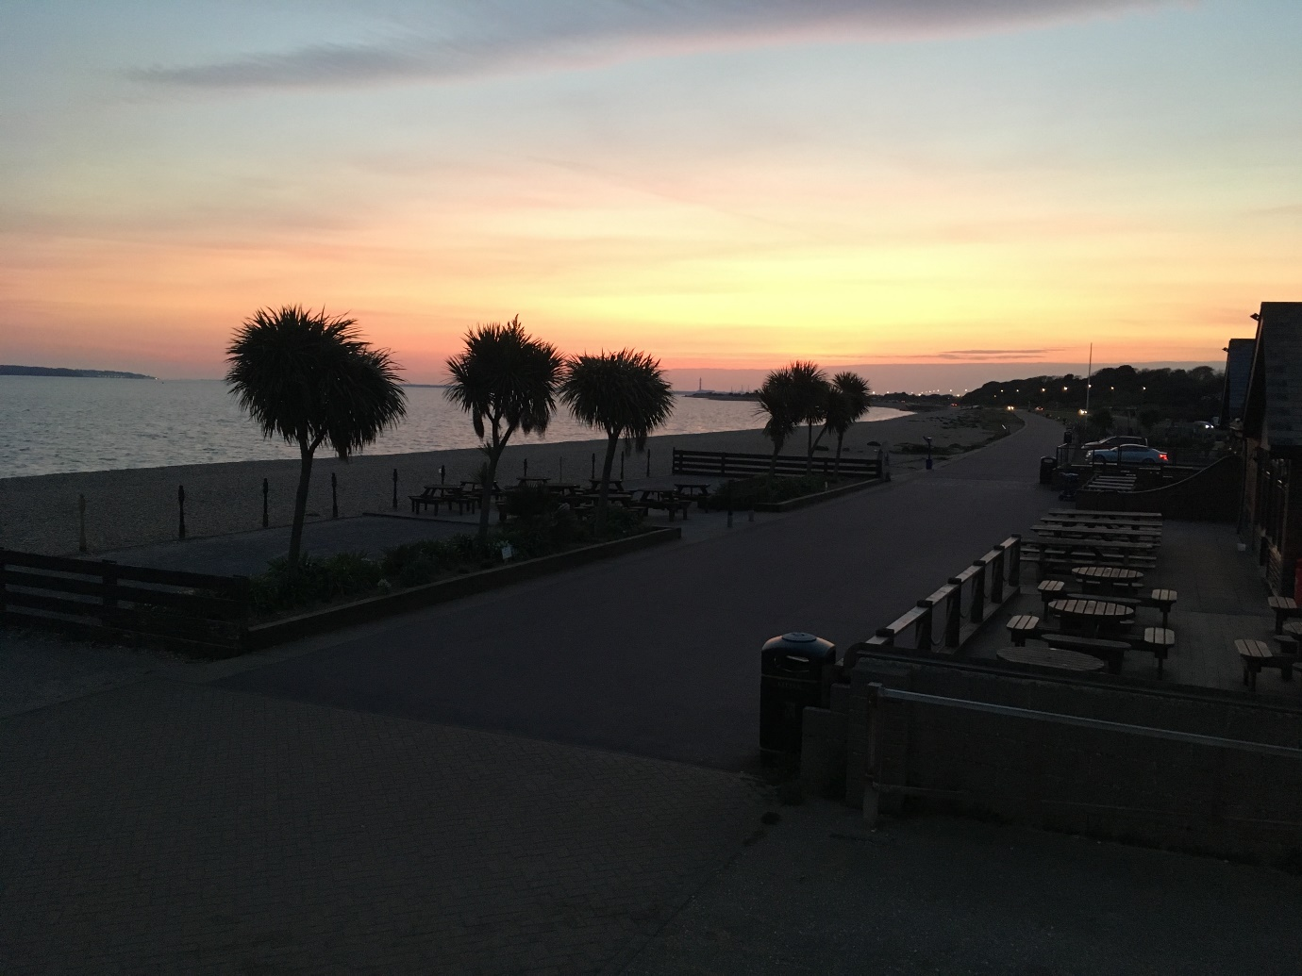3

