Sailing News – February 2021!
Grace asked me to put together another edition of my Sailing News in April last year, so here is what I came up with:-

It was bl**dy windy most of the winter and everything since has been cancelled!

Now we are in 2021 and locked down again, although we did get quite a bit of sailing in over last Summer – all under the RYA’s guidelines, of course.

It has been a weird time but the Committee worked hard to keep us entertained during the various Lockdowns and to ensure that we could safely go sailing again. As the guidelines developed, the Sailing Committee did put together what was necessary for us to start racing over the Summer. Even the Galley and Bar did open, in a very different way, to sustain us before & after sailing! All this WILL happen again this year and we are hoping for some sort of restart sometime in March or April, depending on how all of the infection rates, variants and vaccines go!

Of course, it will still probably all be a bit different, maybe with no changing rooms (OK when the weather is not too chilly!), everyone keeping their distance, as much as possible, and face masks necessary at least for the bridge & handling the Patrol Boat, and new signing-on systems! Not to mention a one-way system in the club room!

Well done to all of those who were involved in getting things up and running last year- with Special Mentions from me for Grace (she tries to do everything!), Karen (lockdown entertainment), Tim (Covid resistant racing), Derek (the new mast and the tractor!), Jo (getting the galley going again) & Bob (for making sure the Clubhouse still works!). Everyone has worked hard under tricky circumstances.

No doubt, the same teams will be doing more to get the Club going again in 2021, as soon as allowed. Sailing Secretary, Peter Mackin has already done a lot of work on Risk Assessments (it’s what he does!) & the Bridge Procedures and is working hard towards a more “automated” bridge system which will save us some duties and make life easier for the dyslexics amongst us! Keep your eyes peeled for communications on Facebook and via email that will explain a couple of little things that we will all need to do. (Don’t worry. It will only take two minutes!)

Having taken the heavy hint to support the Club by renewing membership in good time, many of us are getting the Early Bird advantages promised, with quizzes, Zoom training sessions and raffle draws. What a great job the Club committee is doing in keeping everyone involved and in touch. What a great bunch of volunteers!

As I type this, we have just had a session on the new Racing Rules with local expert, Chris Watts and the Cadets have had a training session with Helena Lucas. Lots of other interesting activities coming up soon too. Just watch your e-mails and the members’ Facebook group.

Club Racing, once it gets under way again, may continue to be wind strength limited, to reduce the likelihood of incidents and the resultant rescues which can increase the risk to those involved. At any time, it is recommended that anyone sailing makes a conservative decision on whether to set sail or not and, of course, to check their equipment thoroughly. It has been in Lockdown too!

The RYA guidelines will vary but we’ll be watching them closely as to when it is OK for two-man boats to be sailed by members of different households and how the Patrol Boat should be manned. Of course, changes will affect the volunteers that we need, but do offer your services where you can or we shall run out of crews and there will be no racing again! The Sailing Committee covered quite a lot duties last year but they do want to go sailing too!

A couple of our “Open” events took place last year but your committees ensured that Club Racing was not affected. Derek & Grace Clark ran a “Pop Up” International Moth Open and the Unicorn Nationals ran with Dave & Louise Roberts taking a lot of the load to make that one work with the final day running within our Club Racing without a problem.

We were hopeful that we would get a full sailing programme this year, but we have already seen the cancellation (or possible postponement) of the Laser Qualifier in March! Classes are still clamouring to come and sail on our special stretch of water and we do hope that the rest of the calendar will survive.
Changes for Club Racing

The Sailing Committee has discussed and agreed some changes for Club Racing, the simplest of which is to move the Lasers ahead of the Dinghy Handicap in the starting order. Flag colours remain the same, Green for Lasers and Yellow for Dinghy Handicap.

Slightly more complicated, but not really, is the addition of the fastest “conventional” dinghies to the Fast Asymmetric Class. Those with a PY of less than 910 will join the earlier start and usually sail Windward/leeward courses. The PY has been chosen to include the 505s and Int Canoes who have generally been starting with that group but not getting their results recorded, which was very unsatisfactory.

The cut-off for boats with asymmetric spinnakers will still be 1002.

These changes will leave the RS 600s, RS 300s and RS200s in the Dinghy Handicap start with triangle courses when practical, which seems to have worked well up to now.

Bay Series – something new to go for!

The eagle eyed amongst those who have paid their subs and received their copies of the Sailing Programme, will have noticed the quarterly addition of the Bay Series on a Sunday.

On these Sundays; March 28th, June 13th, September 5th & December 19th; there will be 3 races counting towards that day’s Bay Series event, whilst the first two will still go towards the usual Sunday series.

There will be prizes for each Bay Series event, and not just for the racing! There will also be overall results for these new events.

Be King or Queen of the Bay Series!

Sailing Newsletter put together by Hugh Myers – all contributions appreciated! hugh_myers@msn.com or 07711 717599

International Moth – by Jason Belben

The Moth fleet at Stokes Bay were active at the club in 2020 despite the situation and the iconic picture that John Donnelly took of Jim McMillian on the first morning of easing of Lockdown 1 showed the eagerness to get going again. It was used nationally by the marine press.

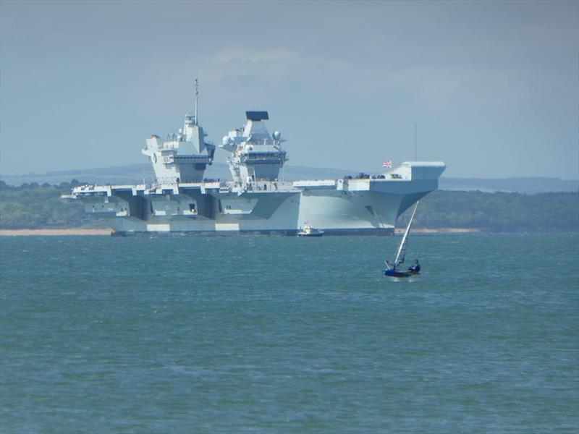

On 12th March at 7.30pm Jason Belben will be running a Zoom session on “Moth set up and going fast tips” as part of the Club’s “Spring into Sailing” activities.

Dinghy Handicap – by Hugh Myers
The Dinghy Handicap Class got off to a great start, or should I say re-start, in 2019 and we want to build on that despite the troublesome times.

We were joined in 2020 by a trio of quick RS600s, a Blaze, at least one more Aero and more Europes than ever before! The winter 2019 growth of the OK fleet stalled a bit with Russ Clark’s posting further west, so his OK was in Weymouth for weekday sailing, and with Matt Howard’s extended Olympic Coaching commitments with Giles Scott. The Class demo boat, which a number of members tried, has now made its way to Weymouth.

Hopefully things will pick up again towards the OK World Championships in Lyme Regis which has now been edged back to 2023 (OMG I’ll be 74 by then!)
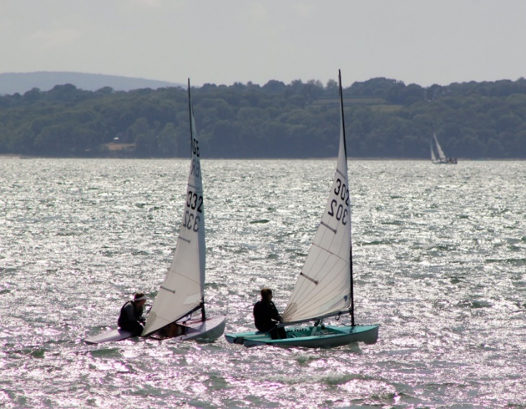
Photo by Louise Roberts

Under the early RYA guidelines most activity was in single handers but as and when things are relaxed, we look forward to the return of our friends in Laser IIs and 420s and anyone else who wants to join in our fun racing. Nick Ireland looked just about ready to join the fray with his granddaughter in a Miracle but now has a Waszp on the way! Apparently, he is a former Miracle National Champion so I did hope that he would not be taking things too seriously!

I am continuing to aim to set repeated triangle courses so that the results for our range of boats can be judged by average lap times when necessary.

Watch out for the Zoom session on Friday 5th March at 8.00pm with Penny & Russ Clark on “Sailing the Bay”. I know that I need all the help I can get!

Lasers

Talking, as I was earlier, about sail numbers for the dyslexics to struggle with, the Lasers have certainly been the most active group in this difficult time and have really bounced back strongly after, for them, a quieter year in 2019.

They did manage to run both National and Masters Championships with Stokes Bay sailors featuring in both. Well done everyone!

Catamaran Fleet – by Dave Roberts
(Photo by Tanya Piper)

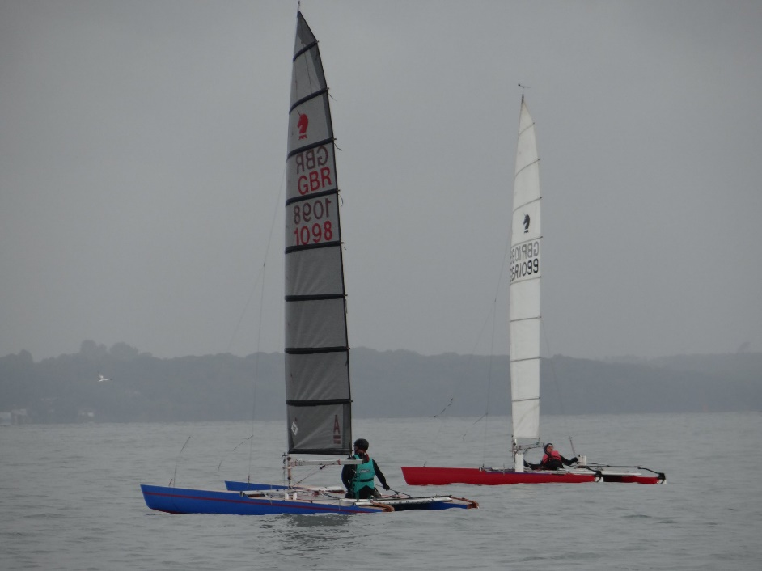

Early in 2020, the double handed catamarans were severely restricted by the social distancing rules; requiring a crew from the same household or social bubble. However, as new RYA guidelines came out, Adam Childsworth raced his Hurricane against Nigel Wade on his Shadow.

A number of other catamarans were seen out cruising.

There is a Cat Handicap WhatsApp group for anyone wishing to check that they will have company when sailing without rescue cover.

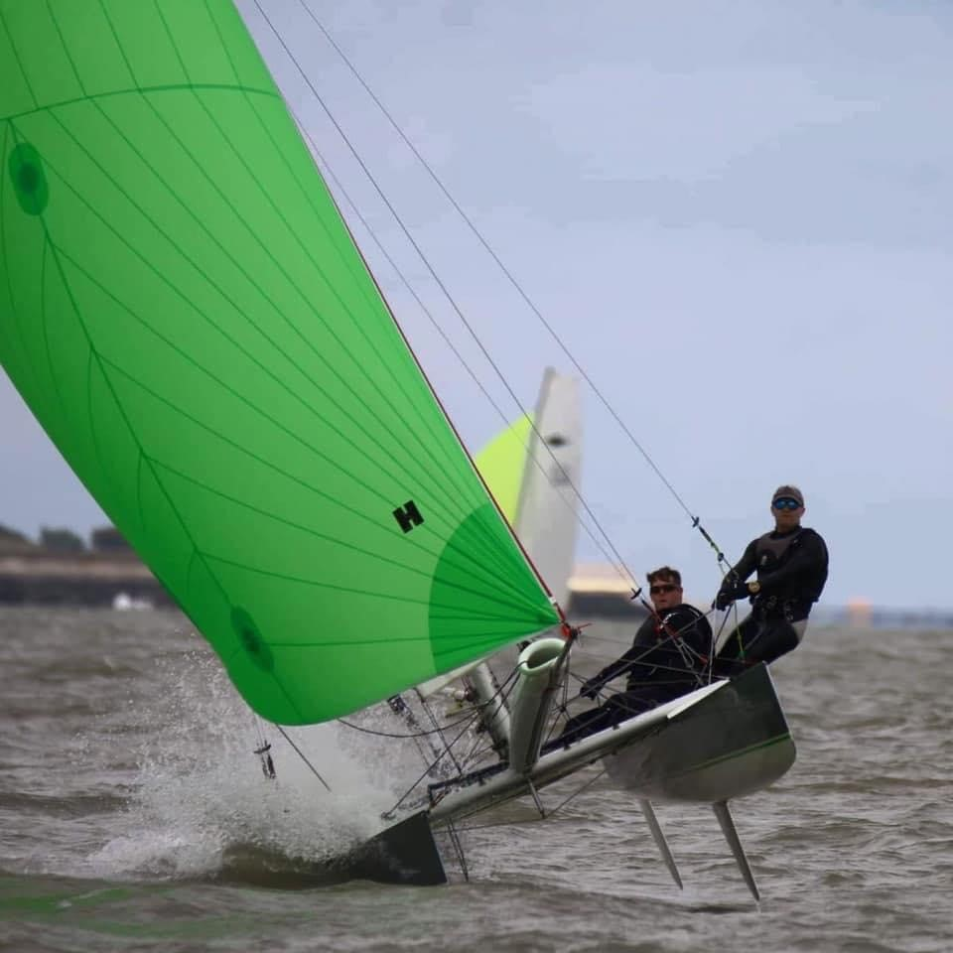
Adam Charlesworth

Dart 18

The highlight event of 2020 was going to be the World Championships in La Rochelle in July, so when that Championship became an early victim of Covid-19, the Dart 18 fleet lost a bit of immediate impetus to train. However, when the lockdown did ease, a number of Dart 18's enjoyed sailing at Stokes Bay - no racing to start with, but just enjoying the great conditions - Andy Kelley, Sue Nelson, Sarah Knott, Paul Chatfield, Nigel Palmer, Mark Holmes, Simon Sinclair, Dave Pollinger & Rebecca have all been sailing. The Dart 18 fleet did get racing again in the club racing on both Wednesday evenings and Sundays.

The next major event is the World Championship in La Rochelle, July 2021.

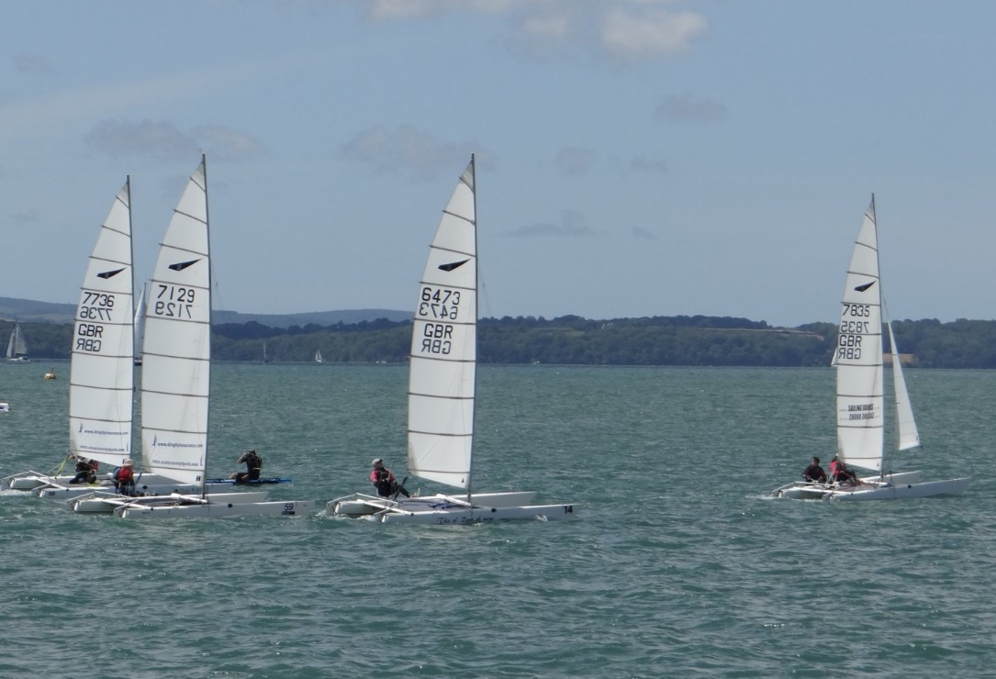

Communication

Most of the Club’s fleets have started WhatsApp groups to keep everyone in touch with what is going on. If you are not yet signed up for your fleet’s group, contact your Class Captain. Details in the Sailing Programme under the Sailing Committee section.

SBSC Cadets
Whats going on in cadets 2021?
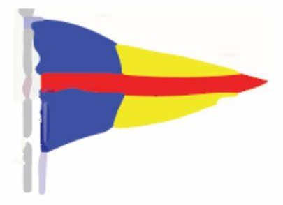  Cadets in 2020  Gavin Brewer  Cadets started again with an unofficial cadet week 2020 where we saw many children getting out and enjoying sailing again, the weather was great the wind was kind and it was just nice to get the children sailing again with their friends.  Saturday cadets also started again where we were having around 15 children every Saturday, we have had some great coaches along the way. With the wind being not quite in our favour for a couple of Saturdays this hasn’t stopped our learning as we have chosen to do some shore based learning which I think is really pay off.  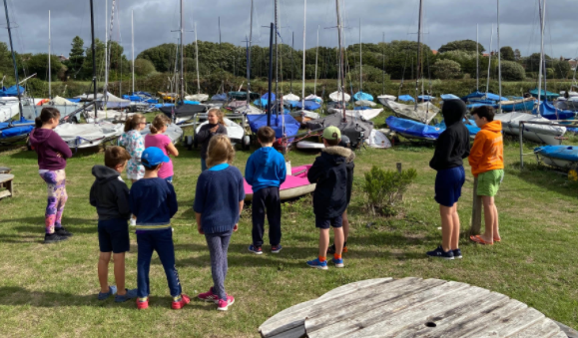  To much wind on this day but that hasn’t stopped the learning.  Picture by Gavin Brewer | 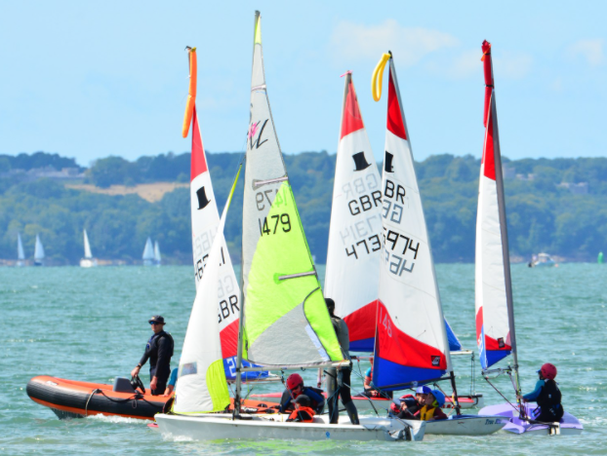  Picture by Lorraine Bugden  What’s in store for 2021
 | Gavin Brewer  Hopefully all being well in 2021 we should get some great sailing god knows we deserve it! Given what 2020 through at us it can only get better.  Some of you will have noticed that both myself and Bruce Keen ran cadets in 2020 with a short lead time to come up with some good ideas and in challenging times with COVID-19 hanging around like a bad smell! That has only made the ideas we have for 2021 that much greater with trying to come up with some fresh ideas and outside the box thinking. So with the 21 season kicking off for cadets in a couple of months’ time we have bought in some different things, the first one that you will notice on the new fixture list is that cadets will not always be run on a Saturday as we will be holding a Cadet championship series which will take place alongside Sunday club racing for four Sundays this year giving us an overall CADET CHAMPION for 2021.  We will also be changing | some of the smaller things in the background that the average person won’t notice but it will be things that will help you (the cadets) out later in life with your sailing skills and knowledge.  We will also be trying to bring a bit more structure to our learning wilst making if fun at the same time.  So with all this in mind and the hope we can get back to normal soon we hope to see as many children out sailing at the club both within cadets and outside of it maybe joining in with some club racing.  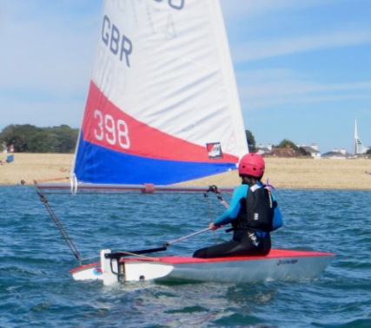  Picture by Lorraine Bugden

