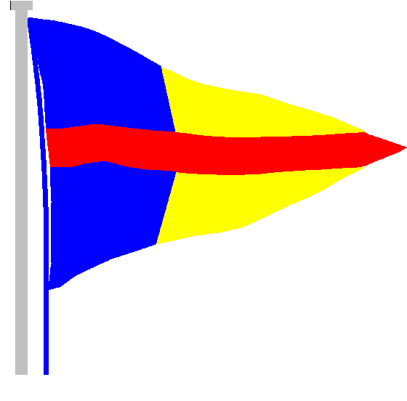
STOKES BAY SAILING CLUB

The Promenade, Stokes Bay Road, Gosport, PO12 2BL
Tel: 023 9258 1513
Email: administrator@stokesbay-sc.co.uk

6th July 2020
Dear Members,

Re: Track and trace

In line with Government legislation, we must track all members who are in the compound each day.

Option 1

Email Debbie at administrator@stokesbay-sc.co.uk to inform her that you will be in the compound.

Option 2

- Go to the signing on board in the club (by the entrance to the ladies changing room).
- Fill in the form.
- Use the hand gel as appropriate.

Please follow this procedure every day that you are in the compound.

Please stay away from the Club if you have any COVID-19 symptoms.

Please send an email to Debbie, at the above address, if anything is unclear so that we can review our decisions, actions and communication as appropriate. We are trying to read, understand and apply Government guidance which is not always that obvious to interpret! As a committee, we have the members at the centre of every decision, and we are doing our very best to open the club facilities and services in a safe and timely manner.

Thank you.

Grace Clark
Commodore

