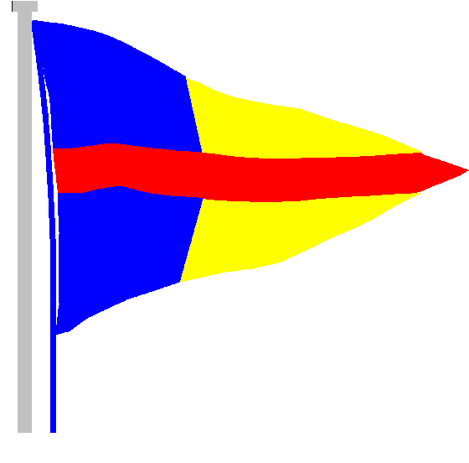
STOKES BAY SAILING CLUB

The Promenade, Stokes Bay Road, Gosport, PO12 2BL
Tel: 023 9258 1513
Email: administrator@stokesbay-sc.co.uk

6th July 2020
RYA Guiding Principles
These are the RYA’s guiding principles that will underpin all guidance across the boating community. We would encourage decision makers to use these principles to inform their own decisions during the Covid-19 period.

- We will always follow Government advice
- The COVID-19 preventative measures are vital to protecting health and wellbeing and to minimising pressure on frontline services. We all have a role to play by following the Government guidelines. Even though you are on the water we do not want to see people setting up races, it is free social sailing only its exercise not an opportunity to have informal racing. Sailing is highly visible and we do not want our actions to appear to be rule breaking.

- We will, as a boating community, take a considerate and conservative approach
- Considerate: be mindful of the potential impact that you could have on other water users and do not place unnecessary extra strain on the RNLI and emergency services. This is a gradual, phased return to sailing.
- Conservative: help to minimise risk by taking an extra conservative approach to your boating. Only sail if there is another club boat sailing within your vicinity who could assist you if required. Take a mobile phone afloat in a waterproof bag with pre dialled numbers of the sailing club office or other shore-based contact.

At this time, it is not possible for the club to provide any safety cover due to the constraints of 2m social distancing, therefore members are urged to exercise extra caution and conservative seamanship before making any decision to launch. Even the best sailors can get caught out by gear failure and while your safety is our first concern, neither the sport nor the club would welcome the negative publicity which might result from a rescue by GAFIRS or worse.

The gate key to the promenade is going to be relocated from the main clubhouse to the left-hand sail locker. It is going to be on a hook directly inside the door on the left until further notice. Please replace the key as soon as you have used it and If you are the last person off the water please ensure that you lock the gate.

In summary, please can you do the following:
- Stay away from the club if you have any Covid-19 symptoms.
- Follow government advice at all times.
- Respect all physical distancing and hygiene guidelines.
- Carry out a thorough check of equipment before going afloat.
- Be considerate and conservative.
- Think long and hard before launching.

Thank you for your continued support and we will continue to update you as any news comes to us.
Best wishes and safe sailing.
Grace Clark
Commodore

