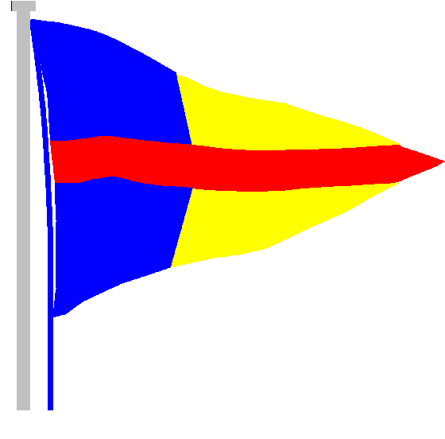
STOKES BAY SAILING CLUB

The Promenade, Stokes Bay Road, Gosport, PO12 2BL
Tel: 023 9258 1513
Email: administrator@stokesbay-sc.co.uk

22nd July 2020
Dear Members,
Re: SBSC Compound Update
We are in the process of a general clean-up of the club compound which requires everyone’s cooperation.
Firstly, could I ask everyone with a berth to have a general tidy up on your next visit to the club.
Anything you wish to store should be located within your berth and not encroach on adjacent berths. If you have a trailer then it must be contained within your own berth or taken away please.
Could you arrange to take away any “rubbish” old masts, car tyres etc that litter the compound and cut your berth so that we can access the tie down cables for inspection.
If anyone has a tip booking and wouldn’t mind taking one of the old sailboards that need disposing of, could they please contact me directly and I can arrange to put one to one side for you to pick up.
All windsurfers that are safe and serviceable are free for anyone to use will now be stored on the rack at the SE corner of the compound.
The current plan is to replace any broken tie down cables, relocate any that are in the wrong position and install intermediate anchor points to try to prevent the cables from lifting. The first stage of the process is to drill d install the new anchor points, followed by replacing the broken cables and relocating cables that are incorrectly positioned.
As soon as the preliminary work is done, we will be requesting small working parties to assist with the installations. This year these could be part of your club duties.
The first phase of the works will prioritise rows A, B, C, S, T, V and the cadet berths. All of these have been identified as broken, loose or too thin. If you have any issues with tie downs that have not already been reported or any suggestions then please address them to me.
Thankyou in anticipation for your cooperation
Greg Goodrum (Red Moth Man)
Compound Officer

